SEKOLAH PENGGERAK SD NEGERI 2 JAMBU

Alamat : Jl.Karengan Karta No.54 RT.04 Kelurahan Jambu, Kab. Barito Utara

**NSS : 101140301029 / NPSN : 30201021** Email : sdnduajambu02@gmail.com

**MODUL AJAR**

Nama Guru : **Sumirnah, S.Pd**

|  |  |  |  |  |  |
| --- | --- | --- | --- | --- | --- |
| Fase/ Kelas | : |  | Mode Pembelajaran | : |  |
| Mata Pelajaran | : |  | Alokasi Waktu | : |  |
| Elemen | : |  | Pendekatan Pembelajaran | : |  |
| Target Peserta Didik | : |  | Dimensi Profil | : |  |

**Kompetensi awal dan sarana yang diperlukan** [*Competence and means*] .

⮳ Kompetensi awal : __________________________________________________________________________________

⮳ Sarana dan prasarana : ______________________________________________________________________________

**Tujuan pembelajaran dan indikator pencapaian kompetensi** [*Learning objectives*] .

⮳ Tujuan pembelajaran : _____________________________________________________________________________

⮳ Indikator ketercapaian : _____________________________________________________________________________

**Pemahaman bermakna dan pertanyaan pemantik** [*Understanding and trigger question*] .

⮳ Pemahaman bermakna

**_______________________**, _________________________________________________________________________

⮳ Pertanyaan pemantik

- __________________________________________________________________________________________________

**Persiapan pembelajaran** [*Preparation*] .

- ________________________________________________________________________________________________

**Kegiatan pembelajaran** [*Learning activities*] .

**Pendahuluan [Alokasi waktu 10 menit]**

➀ Guru memasuki kelas dengan mengucapkan salam dan menanyakan kabar peserta didik.

➁ Peserta didik berdo’a bersama dipimpin oleh satu orang teman.

➂ Guru mengecek kehadiran peserta didik.

➃ Guru mengecek kesiapan belajar dan menyampaikan tujuan pembelajaran hari ini.

**Inti [Alokasi waktu 85 menit]**

➀ ______________________________________________________________________________________________

➁ ______________________________________________________________________________________________

➂ ______________________________________________________________________________________________

➃ ______________________________________________________________________________________________

➄ ______________________________________________________________________________________________

➅ ______________________________________________________________________________________________

➆ ______________________________________________________________________________________________

**Penutup [Alokasi waktu 10 menit]**

➀ Peserta didik diajak untuk merefleksi ketercapaian kemampuannya selama pembelajaran.

➁ Menurut kamu bagian mana, yang paling sulit dari pelajaran ini?

➂ Jika kamu diminta untuk memberikan bintang 1 sampai 5, berapa bintang akan kamu berikan pada usaha yang telah kamu lakukan? Selanjutnya peserta didik dibimbing membuat simpulan pembelajaran.

➃ Guru mengajak peserta didik mengakhiri pembelajaran dengan merapikan alat belajar dan berdo'a bersama.

**Refleksi Guru dan Siswa** [*Reflection*]

|  |  |  |
| --- | --- | --- |
| **Guru** | 1. | Apakah peserta didik memahami materi yang diberikan? |
|  | 2. | Apakah rencana pengajaran berjalan sesuai dengan target? |
|  | 3. | Apakah kendala dalam proses pembelajaran? |
|  | 4. | Apakah pengalaman belajar yang disajikan dapat memotivasi peserta didik? |
|  |  |  |
| **Peserta didik** | 1. | Apa yang kalian lakukan untuk dapat lebih memahami materi ini? |
|  | 2. | Bagian mana materi yang kalian rasa paling sulit? |

**Asesmen** [*Assessment*] .

🗹 Sikap : __________________________________________________________________________________________

🗹 Pengetahuan : ____________________________________________________________________________________

**Pengayaan dan perbaikan** [*Enrichment and remedial*] .

⮳ Pengayaan:

_____________________________________________________________________________________________________

⮳ Perbaikan:

_____________________________________________________________________________________________________

**Bahan bacaan guru dan peserta didik** [*Reading marterial*] .

☞ ______________________________

☞ ______________________________

**Daftar Pustaka :**

_________________________________________________________________________________________________

Muara Teweh, ___________ 2024

**MODUL AJAR OBSERVASI PRAKTIK KINERJA PMM**

**SEKOLAH PENGGERAK** **SD NEGERI 2 JAMBU**

**Tgl. Pelaksanaan ______________ 2024**

|  |  |
| --- | --- |
| Kepala Sekolah,  C:\Users\WIN7\AppData\Local\Microsoft\Windows\Temporary Internet Files\Content.Word\IMG-20240302-WA0008.jpg  **SURIMILAWATI, S.Pd**  PembinaTk.I(IV/b)  NIP. 19720315 199303 2005 | Guru Kelas I,  C:\Users\WIN7\AppData\Local\Microsoft\Windows\Temporary Internet Files\Content.Word\IMG-20240302-WA0009.jpg  **SUMIRNAH, S.Pd**  Pembina (IV/a)  NIP. 19640921 198408 2 002 |

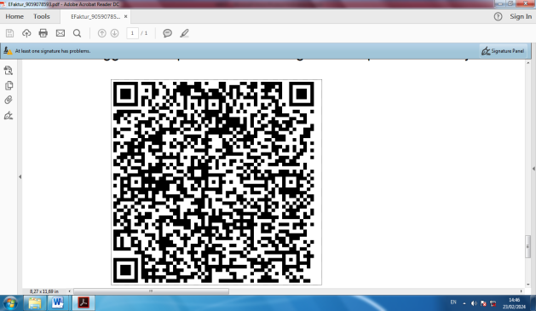

Lampiran :

1. Lembar kerja peserta didik

MA. MP MTK KLS.1

2. Format penilaian sikap dan pengetahuan